SIES COLLEGE OF ARTS, SCIENCE AND COMMERCE (AUTONOMUS), SION WEST, MUMBAI - 400 022

REPORT FORMAT

**A. Title of the Seminar/Workshop/Conferences:** **Inside NMR spectroscopy**

**B. Background:**

In order to emphasize the Golden Jubilee celebration of SIES College of Arts, Science & Commerce ( Autonomous) , Department of Chemistry organised a Webinar on “ Inside NMR spectroscopy “- A popular science Lecture by Indian Women Scientists Association supported by BRNS-DAE on Wednesday , 5th August 2020 at 3 p.m. via MS- Teams platform.

**C. Aims/Objectives:** To know basics of spectroscopy and its application.

**D. Location :** SIES COLLEGE OF ARTS, SCIENCE AND COMMERCE (AUTONOMUS), SION WEST, MUMBAI - 400 022. (online plat form)

E. Target audience/participants with expected number: Professors, teachers, research scholars , post graduate students and degree college students.

**F. Details of Sessions:**

A total of 351 participants registered from 45 different institutes. Participants from BARC, University of Florida, Institute of Science Mumbai & Nagpur, University of Mumbai, Institute of Forensic science, Homi Bhabha Centre for Science Education TIFR Mumbai, Union Christian College - Kerala, St. Xavier's College Ahmedabad, Sathaye College, B. K. Birla College (Autonomous) Kalyan and SIES college actively  participated in the webinar.

                             The webinar began with  welcome address and session details by Mrs. Gayatri Sehgal - Head of Department of Chemistry. Dr. Uma Shankar - Principal SIES College, addressed the participants with energetic and expressive words. Dr. Shyamala Bharadwaj - member of Executive committee and Editor of IWSA gave a concise picture of IWSA and the activities set in motion at IWSA. Dr. George K. Abraham- Senior Associate Professor of the Department of Chemistry introduced the resource person - Prof. Suvarn Kulkarni , Department of Chemistry , IITB and the session topic.

                              Without any delay Prof. Suvarn Kulkarni commenced with his lecture. He initiated the lecture with basics of spectroscopy, moving on to active nuclei, nuclear spin, various types of NMR spectrometers followed by application of NMR spectroscopy including numerical solving based on structure determination etc. The lecture was very much crisp and concise covering almost all the aspects of NMR spectroscopy. Participants endorsed the speaker by posting their questions and comments in the chat box. After the lecture ended, it was followed by an interactive question and answer session. Speaker answered all the questions which were taken up. Participants were content with all the answers.

The webinar ended up with a soulful vote of thanks by

Mr. Shekhar Aiyar - Senior Associate professor, Department of Chemistry.

**G. Session and names of Resource Persons:** Prof. Suvarn Kulkarni, Department of Chemistry IIT Bombay.

**H. Expected outcome:** participants got better understanding of NMR Spectroscopy.

**I. Amount Claim**: NIL

J. Photographs

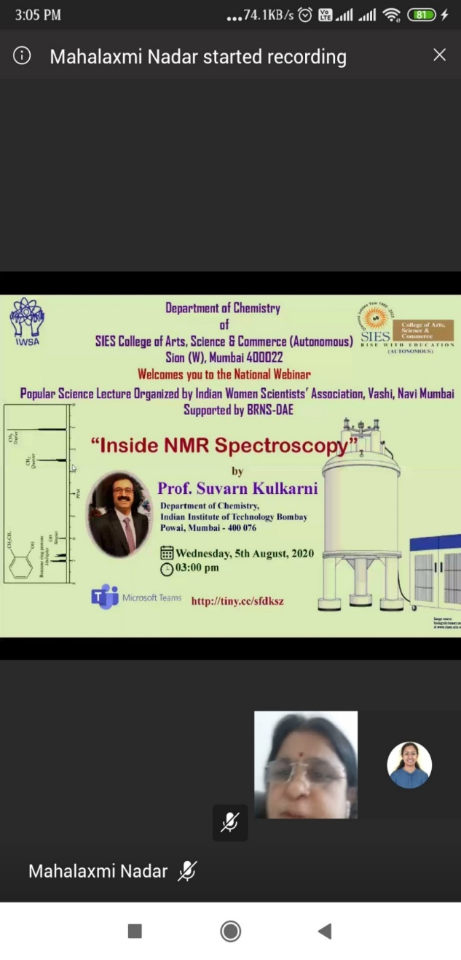

**1. Welcome Address by Mrs. Gayatri Sehgal , Head of the Department of Chemistry**

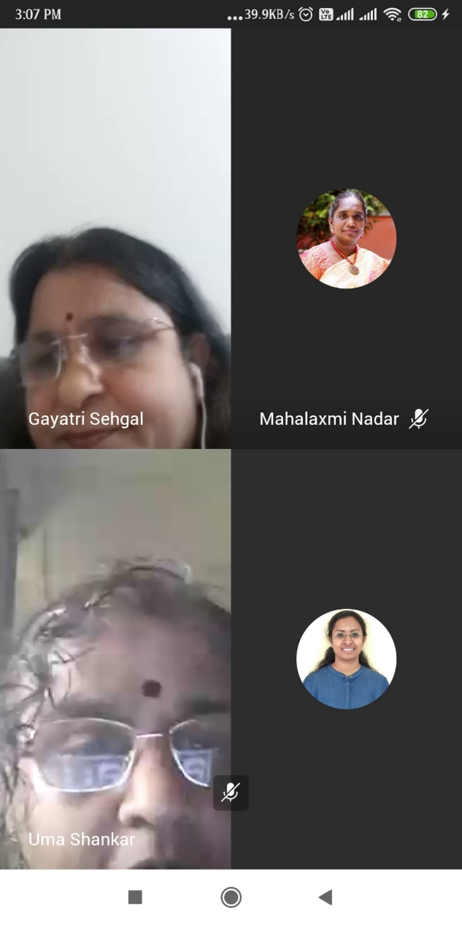

**2. Address by Dr. Uma Shankar , Principal , SIES.**

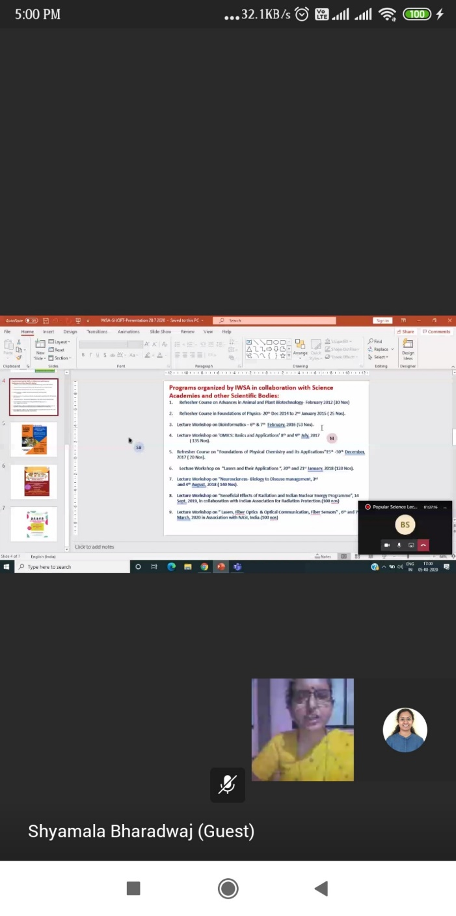

**3. About IWSA by Dr. Shyamala Bharadwaj,**

**Executive member and editor IWSA**

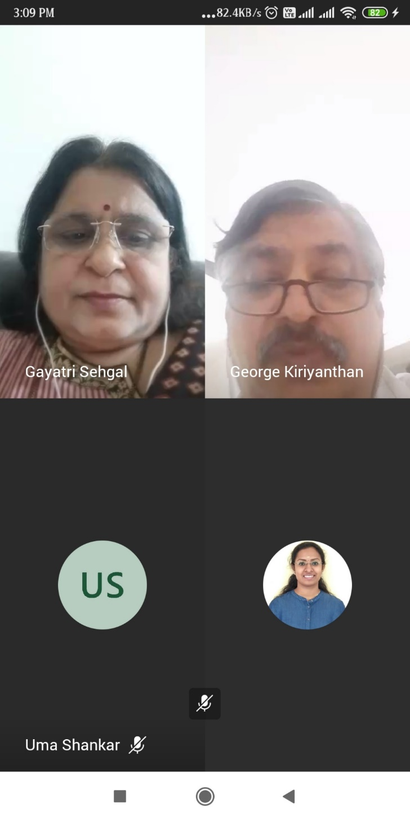

**4. Introduction of speaker and the session by Dr. George Abraham, Associate Professor**

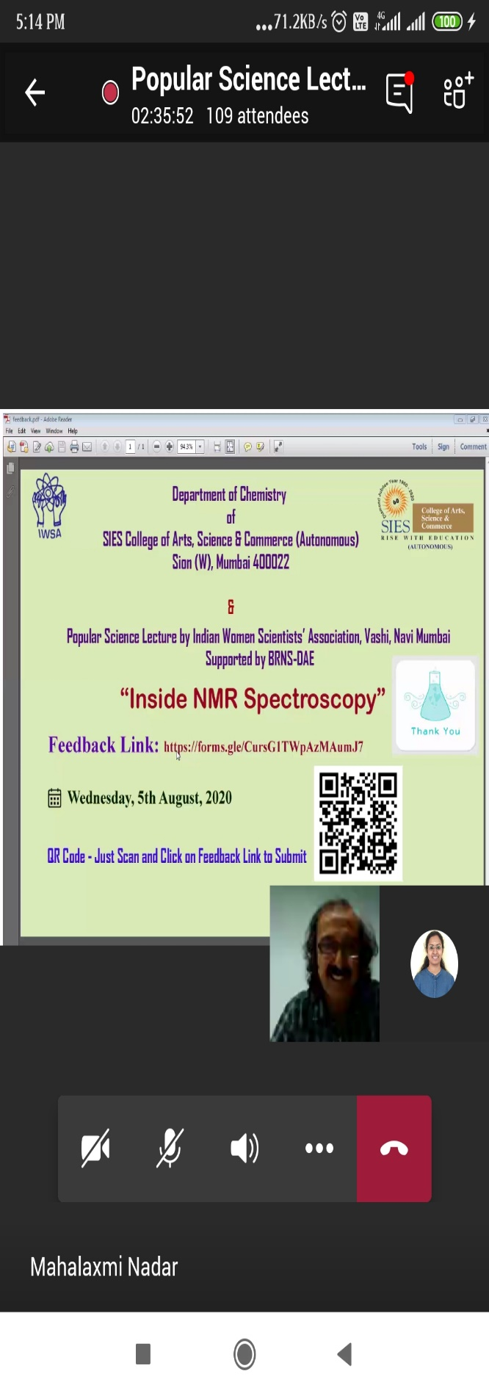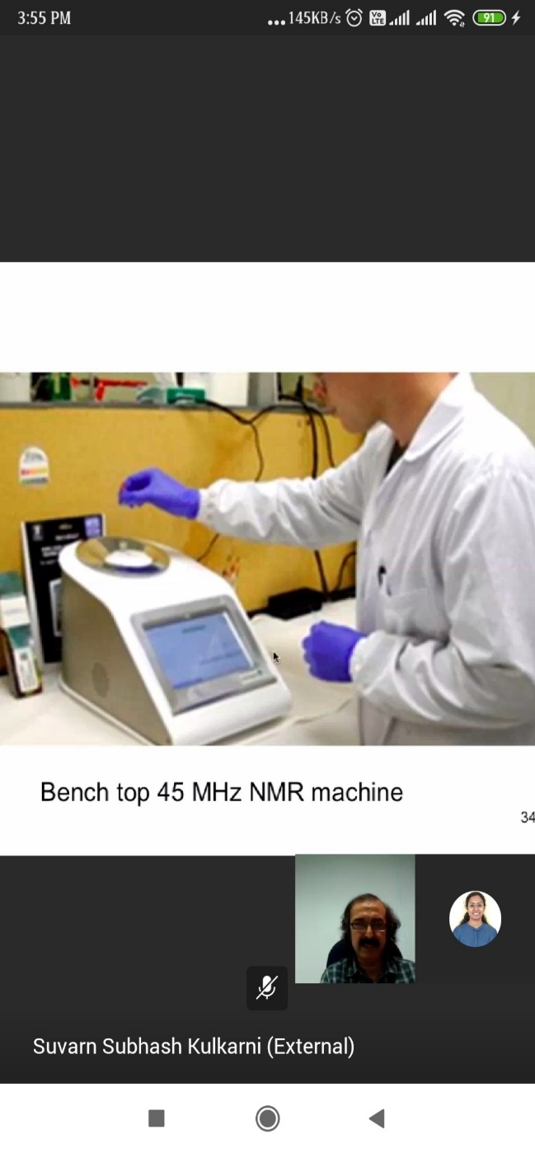

**5 .Lecture by Dr. Suvarn Kulkarni**

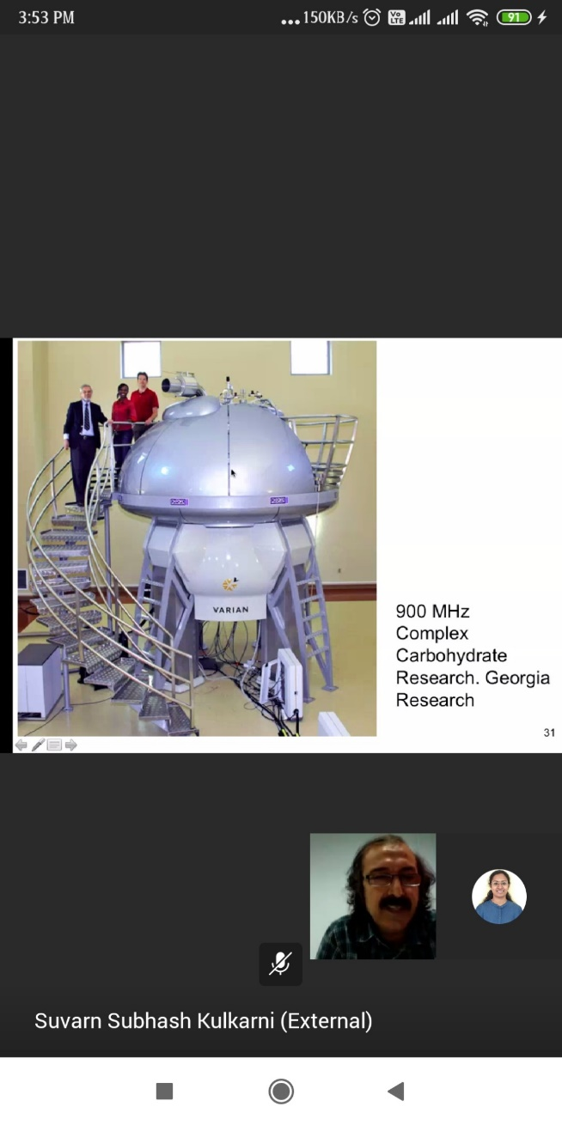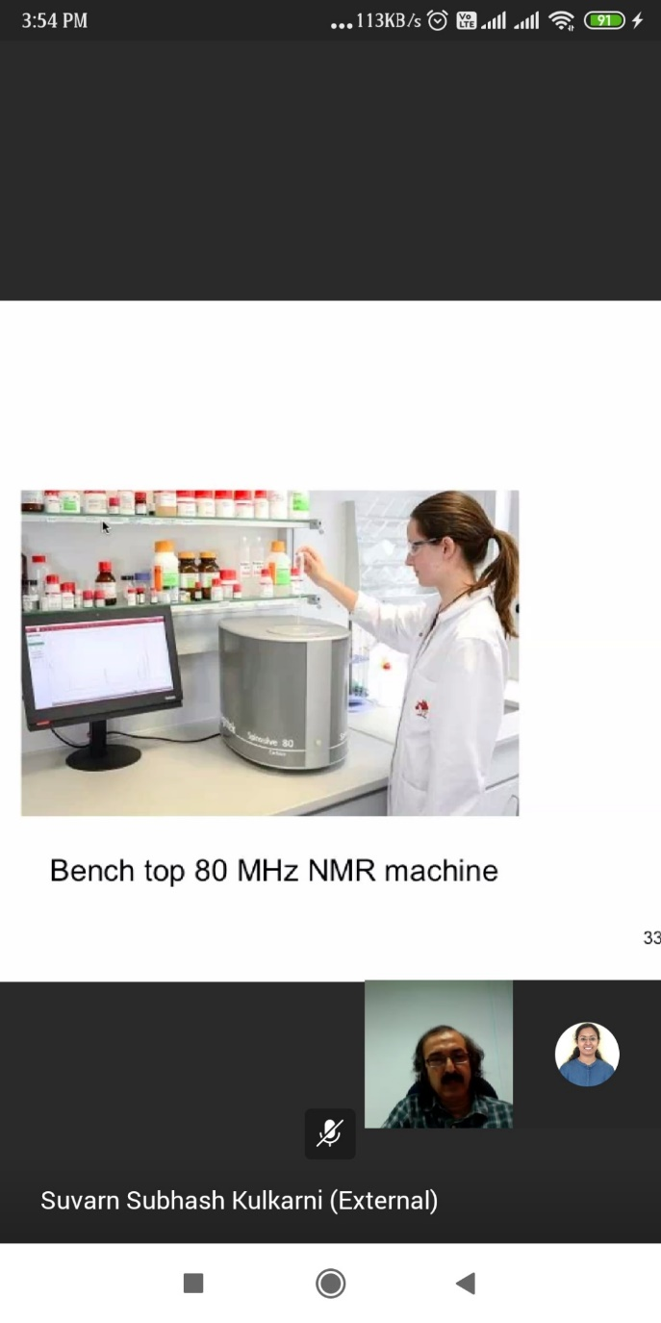

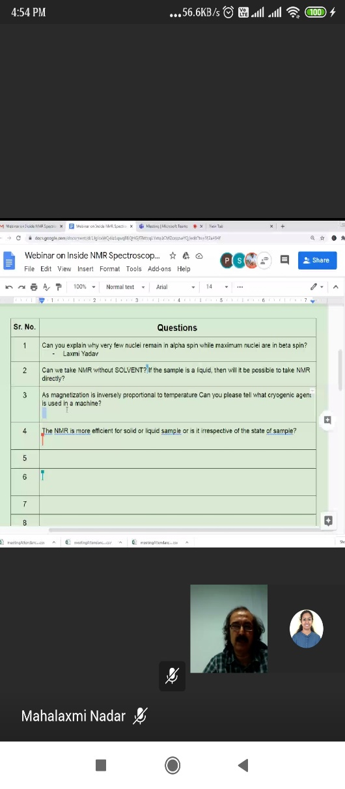

**6. Question Answer Session**

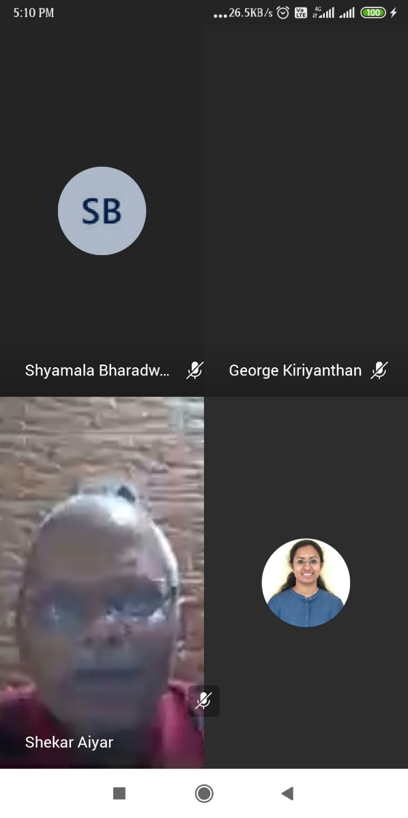

**7. Vote of thanks by Mr. Shekar Aiyar, Associate Professor.**

Annexure:

**i. Detail of the Resource persons:** Prof. Suvarn Kulkarni Department of Chemistry, IIT Bombay.

**ii. List of Participants**

<https://drive.google.com/folderview?id=1rFSo-Rk8GfJUlRZgdDFHo3OQxj6ZmYn6>

**iii. Photographs of Seminar/Workshop**

<https://web.microsoftstream.com/video/58a5b065-3c62-4982-943a-fe264ba6e780>

**You tube link:**

<https://youtu.be/G6SgjW7UYT4>

Report Prepared by

Signature :------------------------

Name : Dr. Madhav S Mane

Department: Chemistry

Designation : Assistant professor

Signature of Principal